Carving of Roman virility found on Britain’s biggest roads project

New find from A14 upgrade is almost 2,000 years old

The team examining the finds unearthed on Britain’s biggest roads project had a surprise when they found one millstone engraved with an enhanced phallus.

More than 300 querns (hand mills) and millstones were recovered during archaeological work on Highways England’s £1.5 billion A14 upgrade between Cambridge and Huntingdon in 2017 and 2018, but this find was only recently pieced together by archaeologists MOLA Headland Infrastructure.

The archaeologists and their partners, Oxford Archaeology, discovered two crosses inscribed on the circumference of the quern, and a different type of carving on its upper face. The millstone had been broken during its use and was then adapted, which preserved the carvings as it was then reversed to be used as a saddle quern, one of the bedstones used in the grinding process, hiding the genital carving.

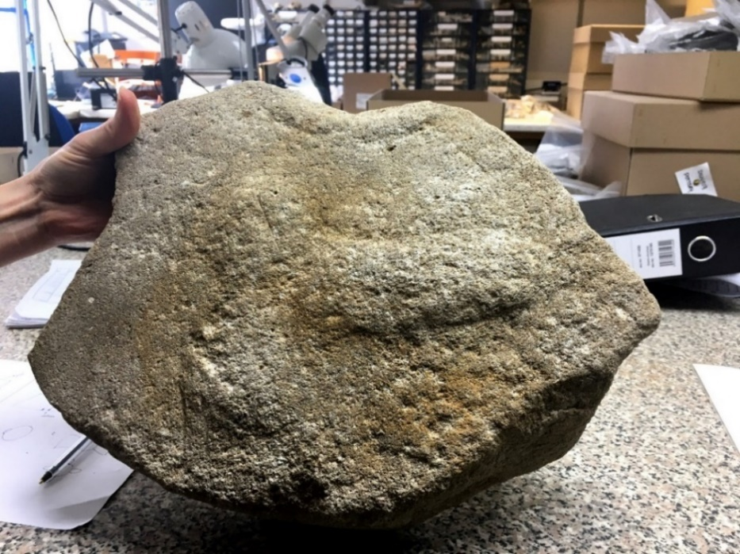
Caption: this millstone found on the A14 has a phallus carved into it

Decorated querns and millstones of any date are extremely rare, with only four such Roman millstones discovered from around a total of 20,000 nationwide. While crosses on such stones are more prevalent, these tend to be found only at military sites.

Steve Sherlock, Highways England’s Archaeology Lead for the A14, said: “This millstone is important as it adds to the evidence for such images from Roman Britain. There were known associations between images of the phallus and milling, such as those found above the bakeries of Pompeii, one inscribed with ‘Hic habitat felicitas’ – ‘You will find happiness here’.

“The phallus was seen as an important image of strength and virility in the Roman world, with it being common practice for legionaries to wear a phallus amulet, which would give them good luck before battle.”
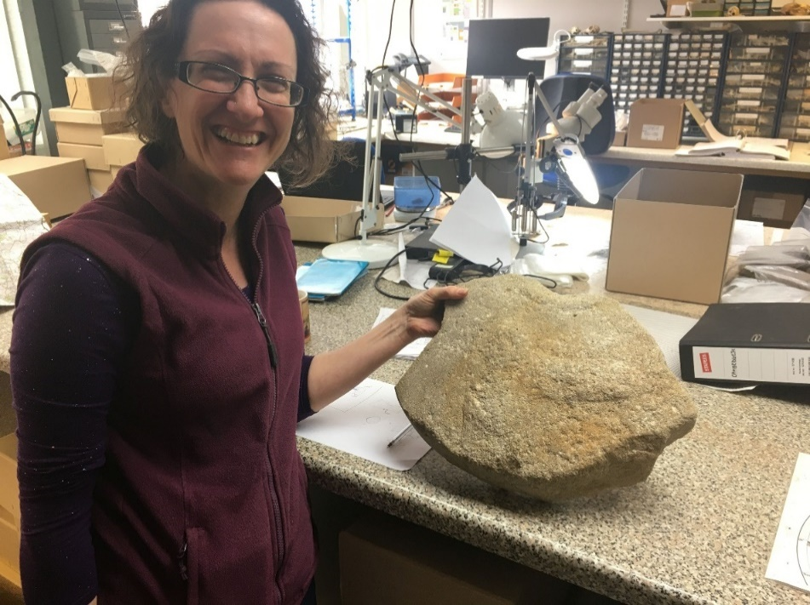
Caption: Dr Ruth Shaffrey with the millstone, only one of four such carvings ever found on these millstones

Dr Ruth Shaffrey, from Oxford Archaeology, added: "As one of only four known examples of Romano-British millstones decorated this way, the A14 millstone is a highly significant find. It offers insights into the importance of the mill to the local community and to the protective properties bestowed upon the millstone and its produce (the flour) by the depiction of a phallus on its upper surface."

Highways England’s trailblazing archaeological work on the A14 has already unearthed woolly mammoth tusks and woolly rhino skulls, the earliest evidence of beer brewing in Britain, dating back to as early as 400 BC, and only the second gold coin to be found in the country depicting Roman emperor Laelianus, who reigned for about two months in 269 AD before he was killed.

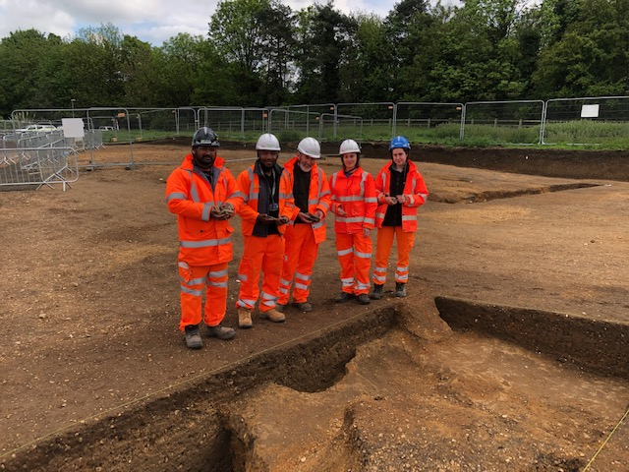
Caption: Preparing for Archaeological open days on the A14 in Huntingdon, summer 2018

The improved 21-mile section of the A14 is a vital link which connects the East coast and the Midlands. It opened some eight months early in May 2020, just before the initial easing of the first lockdown, so it has been able to meet the demand for added capacity at a crucial time.

The new road, which has been Highways England’s flagship project and the biggest investment in a roads project in a generation, is set to bring nearly £2.5 billion of benefits to the UK economy.

With around 85,000 drivers using the section every day before work started, including many more lorries than a typical A-road, the A14 suffered from heavy congestion on a regular basis.

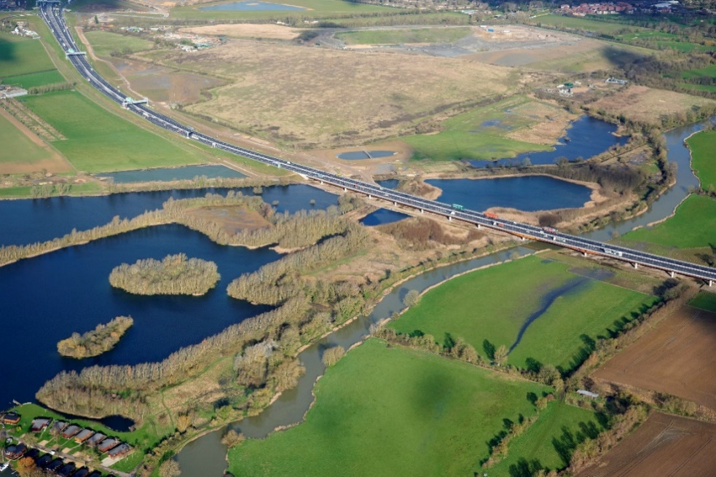
Caption: vehicles using the 750-metre long River Great Ouse viaduct on the new A14

For the latest information about the A14 Cambridge to Huntingdon improvement scheme, including advance notification of road closures, visit www.highwaysengland.co.uk/A14C2H,or follow us on twitter @A428Cat and Facebook www.facebook.com/A428BlackCat, where you can also be kept up-to-date with developments on the A428 Black Cat to Caxton Gibbet improvements.

Ends

NOTES TO EDITORS

- Highways England is the wholly government-owned company responsible for modernising, maintaining and operating England’s motorways and major A roads.

- You can download pictures and drone footage of the project, and a video showing its benefits, here: https://1drv.ms/u/s!AoeN9MzdoO48nm5G6zM2yo3fjpR5?e=s4zZ1D

- The £1.5bn A14 Cambridge to Huntingdon project upgraded 21 miles of the A14 to three lanes in each direction (four lanes between Bar Hill and Girton) adding additional capacity, boosting the local and national economy and cutting up to 20 minutes off journeys.

The project’s major new bypass for Huntingdon opened in December 2019.

The new A14 opened to traffic on 5 May 2020, although some finishing work, such as landscaping as well as foot and cycle paths along the new road and the removal of the A14 viaduct in Huntingdon, continues.

The A14 Cambridge to Huntingdon improvement scheme is being delivered on behalf of Highways England by a joint venture of UK contractors and design consultants: Balfour Beatty, Costain and Skanska and for design, Atkins and CH2M. The delivery team is known as the A14 Integrated Delivery Team.

- To check the latest traffic information for the A14 and other roads, listen to traffic bulletins on local and national radio stations, visit https://highwaysengland.co.uk/traffic/ and follow Highways England on Twitter via @HighwaysEAST.

For the latest information about the A14 Cambridge to Huntingdon improvement scheme, visit www.highwaysengland.co.uk/A14C2H follow @A14C2H on Twitter and like the scheme Facebook page at www.facebook.com/A14C2H/.

- Real-time traffic information for England’s motorways and major A roads is available via its website (www.trafficengland.com), local and national radio travel bulletins, electronic road signs and mobile apps. Local Twitter services are also available at https://highwaysengland.co.uk/highways-england-about-us/.

For further information please contact Highways England’s press office (24hrs) on 0844 693 1448 and select the most appropriate option below:

Option 1: National enquiries (9am to 5.30pm) & out of hours for urgent enquiries
Option 2: North West (between 9am & 5.30pm)
Option 3: Yorkshire, Humber and North East (between 9am & 5.30pm)
Option 4: West Midlands (between 9am & 5.30pm)
Option 5: East Midlands (between 9am & 5.30pm)
Option 6: East (between 9am & 5.30pm)
Option 7: South East (between 9am & 5.30pm)
Option 8: South West (between 9am & 5.30pm)

