**LOCAL FLOOD PREPARATION**

**Why create yet another flood advice document?**

Well after spending months travelling around the Huntingdonshire Parishes and Towns, gathering information on where you live, it became quite evident that the risk of flooding is one of the greatest concerns for many places, especially after the wet weather experienced last winter.

From the places that have already built up great networks, to the ones that are purely in the planning stage, to everyone in between, this document has been created to share, showcase and pass on helpful information. If you are daunted by the prospect of where to begin such a mammoth task, this document may help.

Obviously, best case scenario, the cause of the flooding is rectified by the authorities, but this can take time. Plus, some flooding will unfortunately always happen without warning, particularly in heavy rainfall where there may be flooding in areas that have never flooded before. Remember, flooding does not always come from rivers and the sea. You must also consider risks posed by surface water, groundwater, sewers and other operation failures. We would encourage **All Parishes** to have a form of Flood Risk Planning.

**So, preparation is key:**

Know your emergency numbers, your councils, your agencies and your support groups

.....and help your community to help themselves by creating a great volunteer community network.

**Community support groups can be amazing, show them the way!**

|  |  |
| --- | --- |
| **The bigger picture:** |  |
| The “who is responsible for what flowchart” | Page 2-4 |
| Link to Interactive flood area map | Page 5 |
| Teaming up with your neighbouring parish | Page 6-7 |
| **Your community:** |  |
| How you can help your community prepare | Page 8 |
| A send out message to copy and paste | Page 8 |
| Create a Flood Action Plan | Page 9 |
| Create a Flood Action Group | Page 9 |
| Funding when a Flood Action Plan has been approved | Page 9 |
| Example of a Flood Action Plan | Page 10-11 |
| Example of a Flood Action Website Page | Page 12 |
| Riparian water grants | Page 13 |
| **Key Contacts:** |  |
| Councils, agencies, support groups, mentors | Page 14-15 |

**The bigger picture**

**The “who is responsible for what flowchart”**

[Investigating and Regulating Flooding - Who Manages What (cambridgeshire.gov.uk)](https://www.cambridgeshire.gov.uk/asset-library/Investigating-and-Regulating-Flooding-Who-Manages-What.pdf)

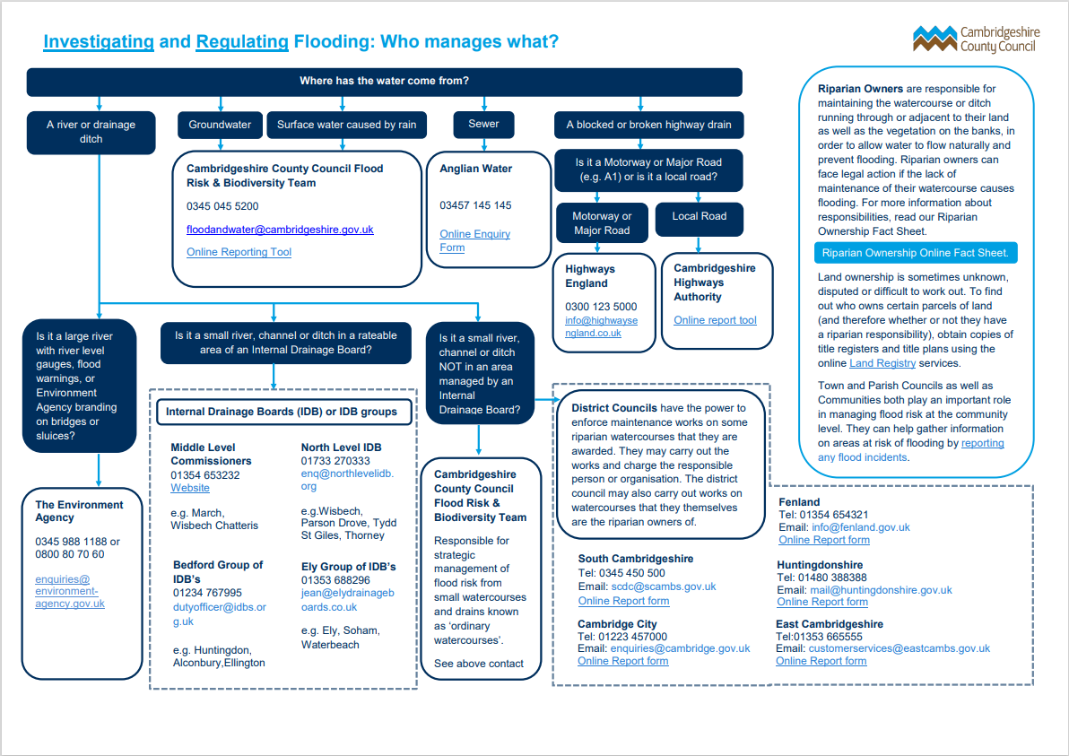

**Managing flood risks: Roles and Responsibilities**

**There is no single body responsible for managing flood risk in the UK because of the role of the devolved administrations in Scotland, Northern Ireland and Wales. Responsibility is joint among a number of bodies.**

**Government**

The Department for Environment, Food and Rural Affairs (Defra) is the policy lead for flood and coastal erosion risk management in England. New or revised policies are prepared with other parts of government such as the Treasury, the Cabinet Office (for emergency response planning) and the Department for Communities and Local Government (for land-use and planning policy). These national policies are then delivered by Risk Assessment Management Authorities (RMAs) which are:

* Environment Agency
* Lead Local Flood Authorities
* District and Borough Councils
* Coast protection authorities
* Water and sewerage companies
* Internal Drainage Boards
* Highways authorities.

**The Flood and Water Management Act 2010 requires these Risk Management Authorities to:**

* co-operate with each other
* act in a manner that is consistent with the National Flood and Coastal Erosion Risk Management Strategy for England and the local flood risk management strategies developed by Lead Local Flood Authorities
* exchange information.

They have flexibility to form partnerships and to act on behalf of one another.

One way RMAs can cooperate is through public sector cooperation agreements (PSCAs). PSCAs allow either party to undertake inland and coastal work and flood incident response on behalf of the other where they agree to do so and where they will achieve cost savings. Reports, templates and briefing notes are available on the Association of Drainage Authorities website.

**Environment Agency**

The Environment Agency has a strategic overview of all sources of flooding and coastal erosion (as defined in the Flood and Water Management Act 2010). It is also responsible for flood and coastal erosion risk management activities on main rivers and the coast, regulating reservoir safety, and working in partnership with the Met Office to provide flood forecasts and warnings. It must also look for opportunities to maintain and improve the environment for people and wildlife while carrying out all of its duties.

**Lead Local Flood Authorities (LLFAs)**

LLFAs are county councils and unitary authorities. They lead in managing local flood risks (i.e. risks of flooding from surface water, ground water and ordinary (smaller) watercourses). This includes ensuring co-operation between the Risk Management Authorities in their area. Under the Flood and Water Management Act 2010, LLFAs are required to:

* prepare and maintain a strategy for local flood risk management in their areas
* carry out works to manage local flood risks in their areas
* maintain a register of assets – these are physical features that have a significant effect on flooding in their area.
* investigate significant local flooding incidents and publish the results of such investigations.
* have powers under the Land Drainage Act 1991 to regulate ordinary watercourses (outside of internal drainage districts) undertake a statutory consultee role providing technical advice on surface water drainage to local planning authorities  major developments (10 dwellings or more)
* co-operate with other Risk Management Authorities
* play a lead role in emergency planning and recovery after a flood event.
* LLFAs and the Environment Agency and  all other Risk Management Authorities need to work closely together and ensure that the plans they are making both locally and nationally link up. An essential part of managing local flood risk is taking account of new development in land use plans and strategies.

**LLFAs should encourage local communities to participate in local flood risk management. Depending on local circumstances, this could include developing and sharing good practice in risk management, training community volunteers so that they can raise awareness of flood risk in their community, and helping the community to prepare flood action plans. LLFAs must also consult local communities about their local flood risk management strategy.**

**District and Borough Councils**

District and Borough Councils are Risk Management Authorities and key partners in planning local flood risk management. They:

* can carry out flood risk management works on minor watercourses (outside of IDB areas),
* work in partnership with LLFAs and other Risk Management Authorities to ensure risks are managed effectively, including in relation to taking decisions on development in their area.

**Coastal protection authorities**

District and unitary authorities in coastal areas are Coastal Protection Authorities. They lead on coastal erosion risk management activities in their area. They are responsible for developing Shoreline Management Plans (SMPs) which provide a long-term holistic framework for managing the risk of coastal change on their section of the coast.

The Environment Agency has a strategic overview to ensure that decisions about the coast are made in a joined-up manner.

**Water and sewerage companies**

Water companies are Risk Management Authorities (RMAs) and play a major role in managing flood and coastal erosion risks. They manage the risk of flooding to water supply and sewerage facilities and flood risks from the failure of their infrastructure.

**Internal Drainage Boards (IDBs)**

IDBs have an important role to play in flood risk management, and in creating and managing natural habitats. Each IDB operates within a defined area, known as a drainage district. They are made up of elected members who represent land occupiers, and others nominated by local authorities who represent the public and other interest groups.

IDBs are independent public bodies responsible for managing water levels in low-lying areas. They are the land drainage authority within their districts and their functions include supervising land drainage and flood defence works on ordinary watercourses.

**They are able to involve local people, encourage volunteering and raise funds from those who benefit from their work**

[**More about IDBs**](http://www.ada.org.uk/) – on the website of the Association of Drainage Authorities

**Highways authorities**

Highways authorities (the Highways Agency and unitary/county councils) have the lead responsibility for providing and managing highway drainage and roadside ditches under the Highways Act 1980. The owners of land adjoining a highway also have a common-law duty to maintain ditches to prevent them causing a nuisance to road users.

They co-operate with the other Risk Management Authorities to ensure their flood management activities are well coordinated.

For more information on all of these authorities please visit:

[Flood and coastal erosion: risk management authorities - GOV.UK (www.gov.uk)](https://www.gov.uk/government/collections/flood-and-coastal-erosion-risk-management-authorities)

**What’s new in ‘22**

The Cambridgeshire County Council Community Flood Action Team aims to explain the above information in a more concise way. They are therefore in the process of producing some guidance for ordinary watercourse ownership/maintenance, and we will be getting some infographics designed which should be available in Jan 2022. We will then be able to share with Parish / Town Councils to use on your documents, websites etc. Giving your community the knowledge to carry out works on ditches and watercourses.

**Interactive flood area map**

**Check out the flood risk in your local area:**

[Huntingdon Flood Map (getthedata.com)](https://www.getthedata.com/flood-map/huntingdon)

The data is sourced from the Environment Agency's Risk of Flooding from Rivers and Sea:

<https://data.gov.uk/dataset/bad20199-6d39-4aad-8564-26a46778fd94/risk-of-flooding-from-rivers-and-sea>

Please Note: this data is not designed for assessing the flood risk to a single property.

**A snapshot from the website:**

**----------------------------------------------------------------------------------------------------------------------------------------------**

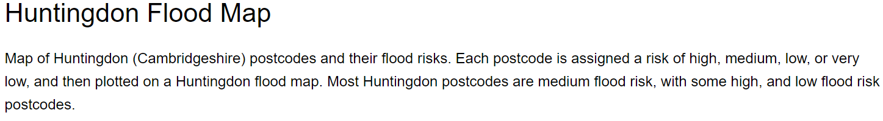

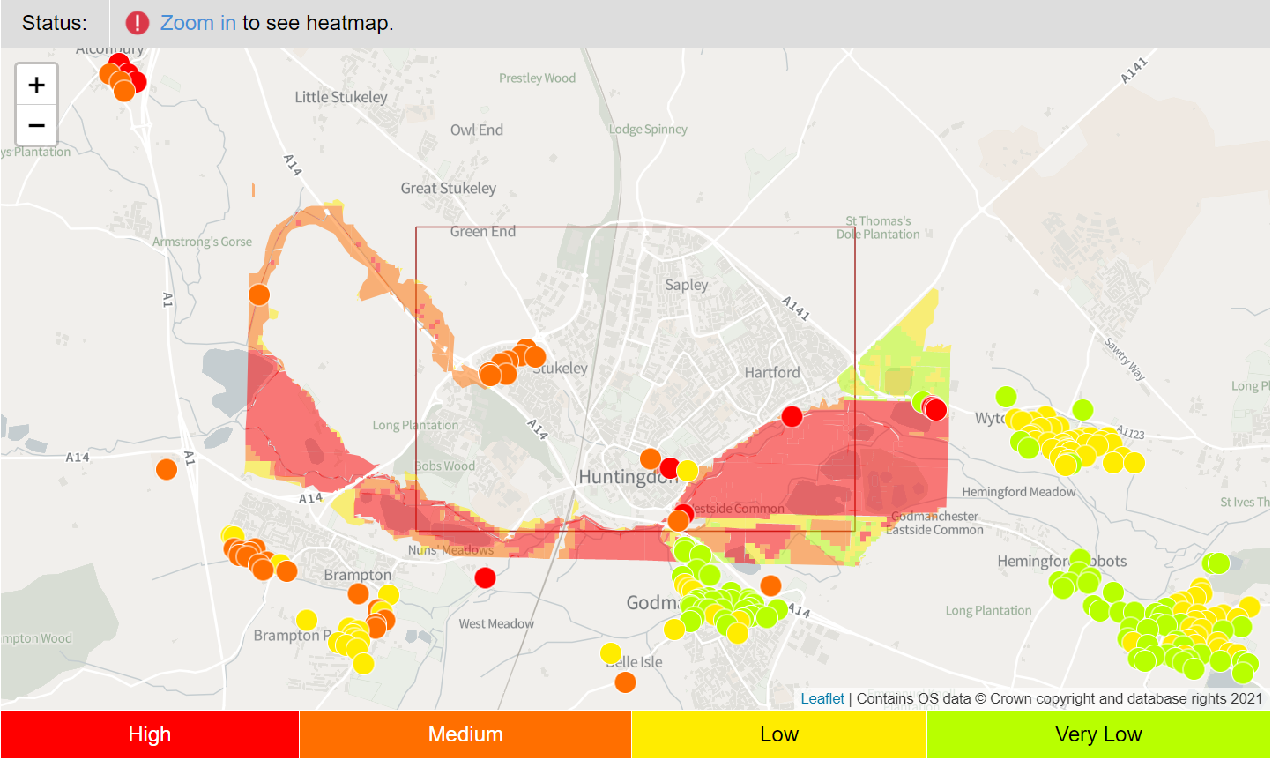

-----------------------------------------------------------------------------------------------------------------------------------------------------------

To include surface water flood risk indicators please follow the link to the Environment Agencies long term flood risk post code search. [Where do you want to check? - GOV.UK (check-long-term-flood-risk.service.gov.uk)](https://check-long-term-flood-risk.service.gov.uk/postcode)

**Can you join up with your neighbouring Parishes – share your experience, knowledge and resources?**

**Contact your neighbour and find out how you can work together:**

|  |  |
| --- | --- |
| Abbots Ripton CP | abbotsriptonclerk@gmail.com |
| Abbotsley CP | clerk@abbotsleypc.org.uk; |
| Alconbury Weston CP | parishclerk@alconburywestonparishcouncil.co.uk; |
| Alwalton CP | alwaltonpc@gmail.com |
| Barham and Woolley CP | clerk@barhamwoolley.org.uk |
| Bluntisham CP | bluntishamclerk@gmail.com |
| Brampton CP | clerk@bramptonpc.co.uk |
| Brington and Molesworth CP | clerk@bringtonandmolesworthparishcouncil.co.uk |
| Broughton CP | broughtonparishcouncil@hotmail.com |
| Buckden CP | clerk@buckdenpc.org.uk |
| Buckworth CP | buckworthclerk@gmail.com |
| Bury CP | parish.clerk@buryparishcouncil.co.uk |
| Bythorn and Keyston CP | clerk@bythornkeystonparishcouncil.org.uk |
| Catworth CP | catworthclerk@gmail.com |
| Chesterton CP | r.hillier142@btinternet.com |
| Colne CP | colnepc@hotmail.co.uk |
| Covington CP | parish.clerk@covington.org.uk |
| Denton and Caldecote CP | denton.flyers@hotmail.co.uk |
| Earith CP | mpinkearithpc@aol.com |
| Easton CP | clerk\_eastonpc@yahoo.co.uk |
| Ellington CP | clerk@ellingtonparishcouncil.gov.uk |
| Elton CP | wendy7wansford@gmail.com |
| Farcet CP | farcetpc@gmail.com |
| Fenstanton CP | clerk@fenstantonparishcouncil.org.uk |
| Folksworth and Washingley CP | Clerk@folksworthwashingley-pc.org.uk |
| Glatton CP | parish.clerk@glatton.org.uk |
| Godmanchester CP | townclerk@gmccouncil.com |
| Grafham CP | clerk@grafhampc.org |
| Great Gidding CP | ggparishcouncil@outlook.com |
| Great Gransden CP | gransdenpc@hotmail.co.uk |
| Great Paxton CP | clerk@greatpaxton-pc.gov.uk |
| Great Staughton CP | gtstaughtonparishclerk@outlook.com |
| Hail Weston CP | dawn@dawn-isaac.com |
| Hamerton and Steeple Gidding CP | hamertonvillage@gmail.com |
| Hemingford Abbots CP | parishclerk@hemingford-abbots.org.uk |
| Hemingford Grey CP | parish.clerk@hemingfordgreyparishcouncil.gov.uk |
| Hilton CP | peterbalicki@yahoo.com |
| Holme CP | holmeparishclerk@gmail.com |
| Holywell-cum-Needingworth CP | needingworthpc@btconnect.com |
| Houghton and Wyton CP | clerk@houghtonwytonpc.co.uk |
| Huntingdon | town.council@huntingdontown.gov.uk |
| Kimbolton CP | clerk@kimboltonandstonely-pc.gov.uk |
| Kings Ripton CP | clerk.kingsripton.pc@gmail.com |
| Leighton Bromswold CP | leightonbromswoldpc@hotmail.com |
| Little Paxton CP | clerk@littlepaxtonparishcouncil.gov.uk |
| Morborne CP | npr803@gmail.com |
| Offord Cluny and Offord D'Arcy CP | clerk@offords-pc.gov.uk |
| Old Hurst CP | parishclerk@oldhurstparishcouncil.co.uk |
| Old Weston CP | oldwestonpcclerk@gmail.com |
| Perry CP | clerk@perryparishcouncil.org.uk |
| Pidley cum Fenton CP | clerk@pidleycumfenton-pc.gov.uk |
| Ramsey CP | ramseytc@ramseytowncouncil.org.uk |
| Sawtry CP | clerk@sawtry-pc.gov.uk natalie.gadsby@yahoo.co.uk |
| Sibson-cum-Stibbington CP | wendy7wansford@gmail.com |
| Somersham CP | clerk@somersham-pc.gov.uk |
| Southoe and Midloe CP | southoe\_pc@yahoo.co.uk |
| Spaldwick CP | clerkspaldwick.pc@gmail.com |
| St Ives | clerk@stivestowncouncil.gov.uk |
| St. Neots CP | clerk@stneots-tc.gov.uk |
| Stilton CP | clerk@stiltonparishcouncil.org |
| Stow Longa CP | stowlongaclerk.pc@gmail.com |
| The Stukeleys CP | clerk@thestukeleys-pc.gov.uk |
| Tilbrook CP | clerk@tilbrookpc.org.uk |
| Toseland CP/Upton and Coppingford CP | p.a.simpson@herts.ac.uk |
| Toseland CP/Upton and Coppingford CP | ctaylor67@btinternet.com |
| Upwood and the Raveleys CP | parishclerk@upwood.org |
| Warboys CP | clerk@warboysparishcouncil.co.uk |
| Waresley-cum-Tetworth CP | clerk.waresleypc@gmail.com |
| Washingly | chris.bodley@alconburyparishcouncil.gov.uk |
| Water Newton CP | waternewtonparishcouncil@gmail.com |
| Winwick CP | clarkejoh@gmail.com |
| Wistow CP | parishclerk@wistowvillage.info |
| Wood Walton CP | woodwaltonpc@gmail.com |
| Woodhurst CP | martin.louisa.jones@gmail.com |
| Wyton-on-the-Hill CP | clerk@wytononthehill-pc.gov.uk |
| Yaxley CP | clerk@yaxleypc.org.uk |
| Yelling CP | phil.himbury@btinternet.com |

**Your community**

**How you can help your community prepare**

Use the send out message to copy and paste into your own Parish documents.

If you are yet to complete a Flood Action Plan share the message on your Parish Website. Encourage your Community to print out the page and keep in case of an emergency. Remember, access to electricals may be limited at time of flood.

The message can be shared on social media platforms. If your Parish doesn’t have its own Facebook Page, or its not well followed, can you reach people in a different way? Was there a Covid Community response group? We realise these support networks were not always established by the Parish Council, but by other key figures in the community willing to give up their time to galvanise community support. Many communicated by the forming of a WhatsApp group which reached out to most of the community, with the ripple effect also reaching those not on social media. Can you use their platform to send out the flood advice?

Create a Parish Poster to put on your Parish Notice Board and in other key areas.

If you have a Parish Magazine then create a pull out that people can easily remove and be encouraged to display on their fridge or inside a prominent cupboard (anywhere it can be seen easily, you never know when it could be needed). This could be an essential way to communicate to those not on social media, but also can be used for all as an action ready document, a quick visual reminder of what to do when faced with flooding and under extreme stress.

|  |
| --- |
| **What to do in a flood**   * **The first priority is to protect lives. Please leave the area if you are instructed to do so by the emergency services and if there is a risk to life call 999 immediately.** * **Check your village Social Media groups for updates that are close to your home and tune in to your local radio station for updates on your area.** * **Turn off your mains power and water and put sand bags in toilet bowls to prevent sewage backflow.** * **Shut all your windows and lock your doors.** * **Empty freezers and fridges if you are able, make sure to leave the doors open.** * **Move people, pets and valuables to a safer place, this could be upstairs if you have one.** * **Know how to quickly create an essential grab bag in case you need to leave your home. This could include medicines, mobile phones and charging cables, home insurance documents, emergency cash or credit cards, provisions for young children (i.e. nappies, baby food).** * **Be cautious, flood water can be very dangerous, whether fast flowing, deep or dirty. If you must enter floodwater where strong footwear, move slowly and carefully and use a stick to check if you are about to step into a hole or tread on something sharp.** * **If possible move your car to higher ground. Do not attempt to drive through flooded roads as the water may be deeper or flowing faster than you think. If driving is unavoidable do so with extreme caution.** * **Watch out for fallen power lines and do not approach them as there is always a potential electric shock hazard.** |

**Sandbags:**

Source your sandbags in advance. The council will provide sandbags to vulnerable people at imminent risk of flooding, but otherwise they can be sourced from local builders merchants or by emailing: [info@floodsense.co.uk](mailto:info@floodsense.co.uk) or [info@multifloodsolutions.co.uk](mailto:info@multifloodsolutions.co.uk)

**Create a Flood Action Plan and Form a Flood Action Group**

If you identify as a place that is prone to flooding it would be wise to develop a Flood Preparedness Plan.

The plan should identify vulnerable points in your town or parish, including homes that are most at risk, and bring together Flood Groups made up of residents that are willing to spring into action as soon as there is a risk of flooding.

Advertise for volunteers on your website, social media platforms, village noticeboards and local magazines. Hold a meeting to galvanise support, or sign people up after an event or in places of high footfall. The more people you have signed up to volunteer the more prepared you will be – although most communities are normally fabulously reactive in these situations a proactive group will be able to work safely and swiftly for better outcomes.

In order to help you prepare, Cambridgeshire County Council is offering training to all members of the flood groups who would like to know what could be done to support your community. It is also a great place to learn about the role of the water companies, the Environment Agency and your county’s Highways Team and their schedule of gully clearances and repairs.

**Funding when a Flood Action Plan has been approved**

Cambridgeshire County Council are currently trying to get as many community flood groups in place across the county as possible, and to get flood plans written and approved by the Environment Agency. Once approved, communities will be eligible for a £1500 ‘flood kit’ of equipment that can aid support during the time of a flood. This is Local Levy fund and there is a bit of a time limit on its availability, so we are really pushing to get as many written and approved as we can over the next couple of years.

**Contacts:**

For advice on writing your flood action plan, Flood Action Plan training and advice on funding please contact:

[Charles.Krolik-Root@cambridgeshire.gov.uk](mailto:Charles.Krolik-Root@cambridgeshire.gov.uk)

Community Flood Action Programme Manager

Flood Risk and Biodiversity Team

Cambridgeshire County Council

Or contact the Environment Agency directly for Flood Plan Assistance:

[tamsyn.ellway@environment-agency.gov.uk](mailto:tamsyn.ellway@environment-agency.gov.uk)

**There are also some brilliant resource pages provided by Huntingdonshire District Council who would also encourage you to work with them to devise your own flood plan.**

[Flooding - Huntingdonshire.gov.uk](https://www.huntingdonshire.gov.uk/environmental-issues/flooding/)

**An Example of a Flood Action Plan.**

This information has kindly been shared by Fenstanton Parish Council who are more than happy to assist, answer queries or mentor any Parish wishing to set up their own Flood Action Plan.

Contact: <mailto:kevin.mitchell@fenstantonparishcouncil.org.uk>

**The Flood Group Process Map:**

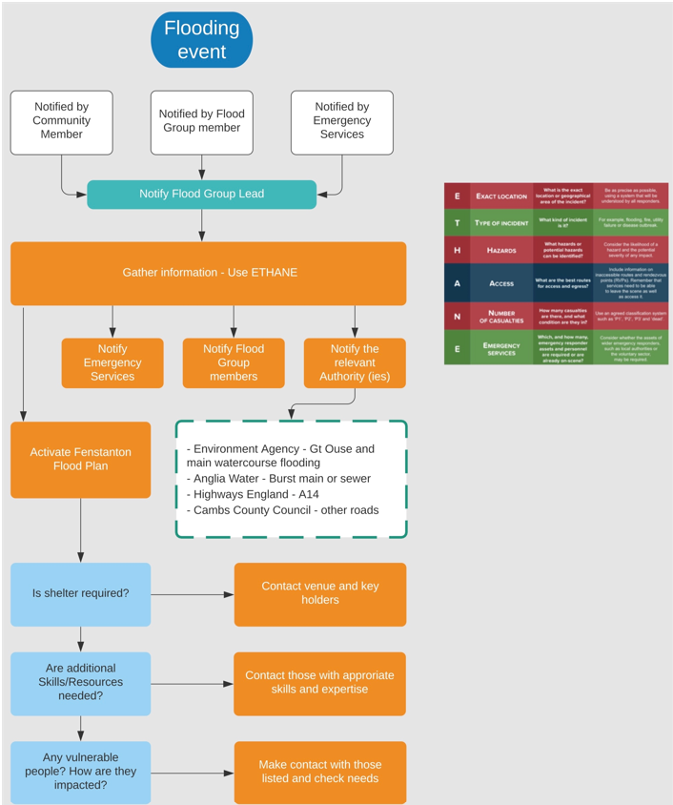

**The Flood Action Plan:**

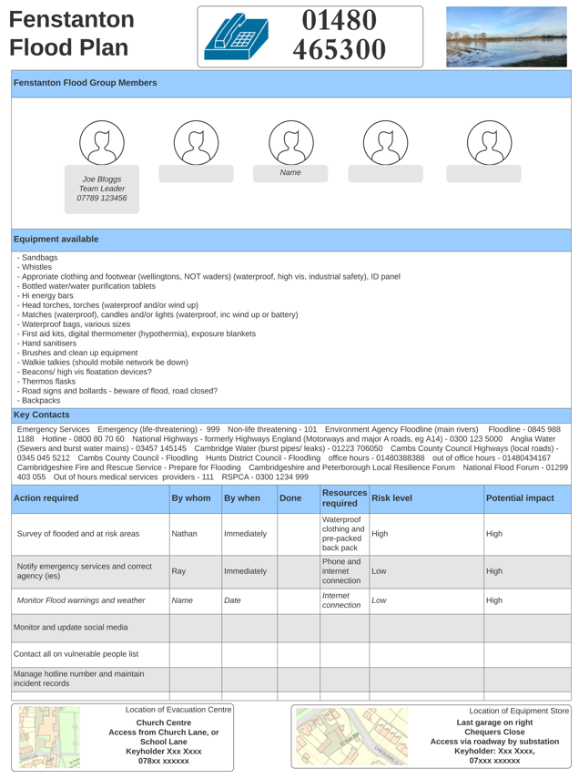

**An Example of a Flood Action Website Page**

This information has kindly been shared by Fenstanton Parish Council who are more than happy to assist, answer queries or mentor any Parish wishing to set up their own Flood Action Plan.

The Parish Council advise that the Fenstanton website content has been worked on within the Parish. However, they have shared the information etc, in whole or part via dropbox with other Parishes, including Fen Drayton, Hemingford Grey, as well as with Doug Dew, their CCC member.

If you need help replicating something similar in your Parish please contact Kevin Mitchell – Fenstanton Parish Councillor.

Contact: [kevin.mitchell@fenstantonparishcouncil.org.uk](mailto:kevin.mitchell@fenstantonparishcouncil.org.uk)

**A snapshot of the webpage:**

**------------------------------------------------------------------------------------------------------------------------**

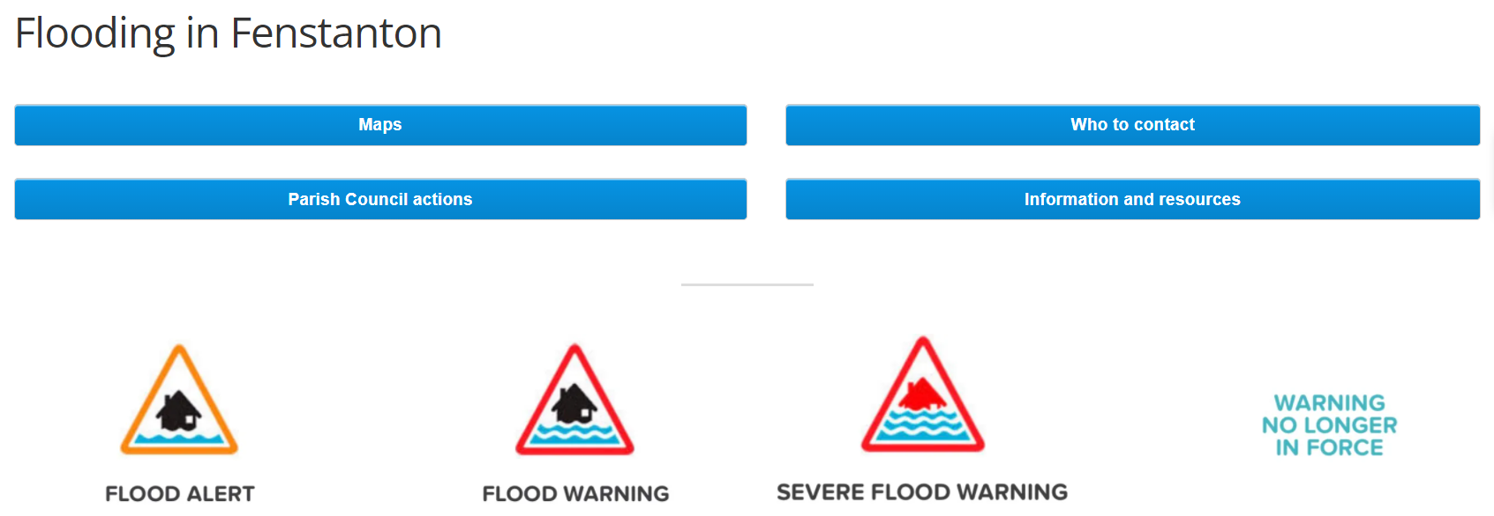

**----------------------------------------------------------------------------------------------------------**

**Please use the link below to view the website pages in full**

[https://fenstantonpc.org/flooding/](https://hes32-ctp.trendmicro.com:443/wis/clicktime/v1/query?url=https%3a%2f%2ffenstantonpc.org%2fflooding%2f&umid=2b95dada-97b9-40ac-b2c3-07404ba8d4fd&auth=73bef1691750f88fd854efaaa37c6473a4e78491-63da6e12242b3ba152aee8c35d872bac6580e5bf)

**Community Flood Groups are being encouraged to apply for a new watercourse grant, to help protect vulnerable properties from flooding.**

The riparian watercourse grant aims to provide funding to communities in Cambridgeshire where riparian owners cannot be identified (either by communities or the County Council) or where riparian owners are unable to undertake riparian maintenance themselves. In addition, certain applications for funding will be given special consideration to ensure that smaller, more rural, and more isolated communities or residents, are not excluded.  
  
Members of the Environment and Green Investment Committee met in September 2021 and agreed to launch the new fund.

A key aim of this initiative by Cambridgeshire County Council, is to increase the resilience of communities to flooding and to encourage communities to form flood action groups.

There are hundreds of watercourses in Cambridgeshire, all of which have a responsible ‘riparian owner’. The riparian owner is the landowner whose land the watercourse is either in, or neighbours.

If you rent the land you should agree with the owner who should manage these rights and responsibilities.

Riparian ownership is well recognised in law with many solicitors producing information about it online, but it’s often still not common knowledge among the communities it affects. Many residents do not realise that they are riparian owners and have responsibilities for watercourses on or next to their property.

As a result, there is a widespread lack of regular watercourse maintenance around the county, causing issues like ‘trash screens’ to be blocked with litter, which holds water back and causes flooding.

* Applications for funding will be assessed on a number of criteria, these include: addressing recognised flooding issues; engaging with the local community; and ecological benefits, amongst others. Applications will be reviewed every two months, beginning in December 2021.

For more information on how to apply for a grant, along with guidance on how to form a Community Flood Action Group, visit: [https://www.cambridgeshire.gov.uk/business/planning-and-development/flood-and-water/riparian-watercourse-grant](http://tracking.cambridgeshire.gov.uk/tracking/click?d=zjSMA2yVn4-mnd4vogjjBwEcgFvDHFybZA0YgJ46PZI8KEBH0v-qqFYZvxw9ovJZg-Zn4Laygj4zbob7QTrox0kAuuSlX-NTdustjoWz7Tuccf01bSccN6Ob6GICG0-3HG5StBvhHOAscuXuDq3MVR6iKDknPHViS9POH9_6bNP3UcSOECz1hC_AEFQMbgfQlPzysyWJLovcbiJyVQMiqU4B_kNbIINxm3n_LvrNM-Sd08T6IsDMpYdhDXL75vDg0A2)

**KEY CONTACTS:**

* Emergency Services
  + Emergency (life-threatening) – 999
  + Non-life threatening – 101
* [Environment Agency Floodline (main rivers)](https://www.gov.uk/report-flood-cause)
  + Floodline – 0845 988 1188
  + Hotline – 0800 80 70 60
* [National Highways – formerly Highways England (Motorways and major A roads, e.g A14)](https://highwaysengland.co.uk/road-safety/travelling-in-severe-weather/) – 0300 123 5000
* [Anglia Water (Sewers and burst water mains)](https://www.anglianwater.co.uk/services/sewers-and-drains/flooding/) – 03457 145145
* [Cambridge Water (burst pipes/ leaks) –](https://www.cambridge-water.co.uk/household/my-water-supply/flooding)01223 706050
* [Cambs County Council Highways (local roads) – 0345 045 5212](https://www.cambridgeshire.gov.uk/business/planning-and-development/flood-and-water/report-a-flood" \l "report-a-flooding-problem-on-roads-and-pavements-0-1" \t "_blank)
* [Cambs County Council - Flooding](https://www.cambridgeshire.gov.uk/search?term=flooding)
* Emergency number - 0300 303 8389
* [Hunts District Council – Flooding](https://www.huntingdonshire.gov.uk/environmental-issues/flooding/)
  + office hours – 01480388388
  + out of office hours – 01480434167
* [Cambridgeshire Fire and Rescue Service – Prepare for Flooding](https://www.cambsfire.gov.uk/community-safety/be-prepared-for-an-emergency/prepare-for-flooding/)
* [Cambridgeshire and Peterborough Local Resilience Forum](https://www.cambsfire.gov.uk/community-safety/be-prepared-for-an-emergency/cambridgeshire-and-peterborough-local-resilience-forum-cplrf/)
* [National Flood Forum](https://nationalfloodforum.org.uk/about-flooding/during/during-a-flood/) – 01299 403 055
* [Out of hours medical services providers](https://www.nhs.uk/service-search/other-services/UrgentCare/UrgentCareFinder?Location.Id=0&Location.Name=Pe28%209jw&Location.Latitude=52.3008003234863&Location.Longitude=-0.0670409053564072&IsAandE=True&IsPharmacy=False&IsUrgentCare=False&IsOpenNow=False&MileValue=20) – 111
* [RSPCA](https://www.rspca.org.uk/local/aboutus/-/rspca/cambridge-and-district-branch) – 0300 1234 999

**Utilities and services**

* [National Grid Gas leaks](https://www.nationalgrid.com/uk/gas-transmission/safety-and-emergencies/emergencies-and-safety-advice) – 0800 111 999
* [National Grid Power cuts – Electricity Helpline](https://www.nationalgrid.com/uk/electricity-transmission/contact-us/power-cuts) – 105
* [UK Power Networks (powerlines)](https://www.ukpowernetworks.co.uk/internet/en/help-and-advice/report-it/report-danger-form/) – 0800 111 999
* [AA – breaking down in a flood –](https://www.theaa.com/driving-advice/seasonal/driving-through-flood-water)0800 88 77 66

**Local**

* Vets/animal rescue
  + [Wood Green animal shelter](https://woodgreen.org.uk/contact-us/pet-support) – 0300 303 9333
* Radio/TV/News
  + [Cambridgeshire Live](https://www.cambridge-news.co.uk/)
  + [Hunts Post – online](https://www.huntspost.co.uk/news)
  + [BBC Radio Cambridgeshire – 95.7FM](https://www.bbc.co.uk/sounds/play/live:bbc_radio_cambridge)
  + [Huntingdon Community Radio](https://www.hcrfm.co.uk/) – 104FM

**Flood Clear up**

* [National Flood Forum – Flood Recovery Services](https://nationalfloodforum.org.uk/working-together/working-with-professional-partners/flood-recovery-services/)
* [Financial Ombudsman Service – Flood Damage](https://www.financial-ombudsman.org.uk/consumers/complaints-can-help/insurance/home-insurance/flood-damage)
* [The British Damage Management Service – Flood advice](https://bdma.org.uk/publications/flood-leaflet-1/)
* [Citizens Advice – Flooding](https://www.citizensadvice.org.uk/resources-and-tools/search-navigation-tools/Search/?c=HOME&q=Flooding)

Other Support:

Mathew Setchell, chair of the St.Ives Action Flood Group and co – chair of Stop the Floods is also willing to offer any advice or support.

Email contact: mathew.setchell@mshsupport.co.uk

**We hope this document has been a useful start for those daunted by the prospect of Flood Preparedness.**

**Please do not hesitate to contact the Hunts Think Communities Team for any further information.**

**We are happy to support and signpost where we can.**

The Huntingdonshire Think Communities Team

Community.huntingdonshire@cambridgeshire.gov.uk

Follow Think Communities Huntingdonshire:

 @[TCHunts](https://www.facebook.com/TCHunts)

@[TC\_Hunts](https://twitter.com/TC_Hunts)