Wildlife Ponds - Funding Available!
Ponds are a cherished part of the parish landscape; familiar historic features found at the heart of most village centres and in the wider countryside. Sadly, due to changes in land use and agricultural practices, the UK has lost around 50% of ponds in the 20th Century. Those remaining are often threatened by pollution. This means the many species of plant and animal that rely on them are also under threat.
Excitingly, funding is now available in certain parts of Cambridgeshire for the restoration and creation of clean water wildlife ponds capable of supporting great crested newts. The funding is part of Natural England’s District Level Licencing scheme (DLL), a new strategy for compensating the loss of newt habitats, which seeks to provide new ponds and bigger, better, more joined-up habitat for this orange-bellied amphibian at a landscape scale.
In Cambridgeshire there is a high demand for such wildlife ponds through the DLL scheme. Most of the 150 or so pond projects we have delivered to date have been fully funded under the scheme. You can view some of these projects at: www.fwageast.org.uk/ponds.
We are seeking local farmers, smallholders, large rural garden owners, land-based businesses and parish-owned land to create and restore more such ponds. If you have a location in mind in your parish, please email ponds@fwageast.org.uk to receive further information or arrange an informal chat. Let’s do something brilliant for wildlife!
A recently created farmland pond – Credit J McNaughton, FWAG East
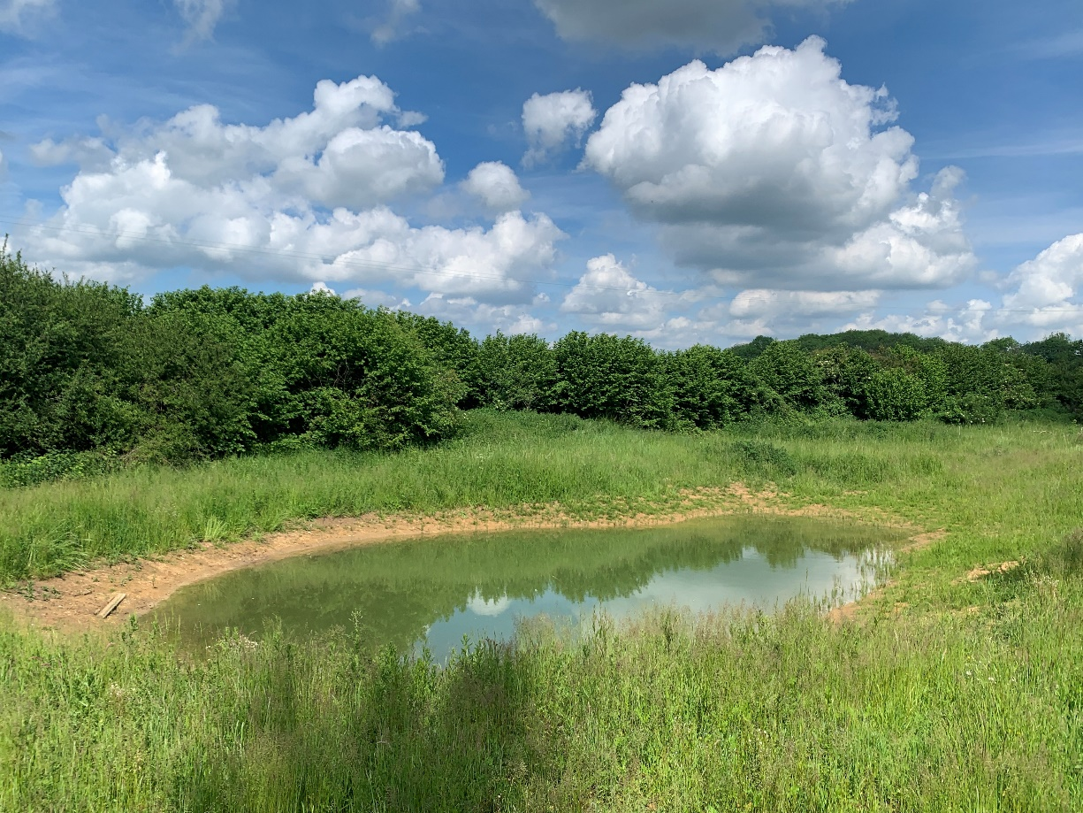
A recently restored parish pond - Credit J McNaughton, FWAG East
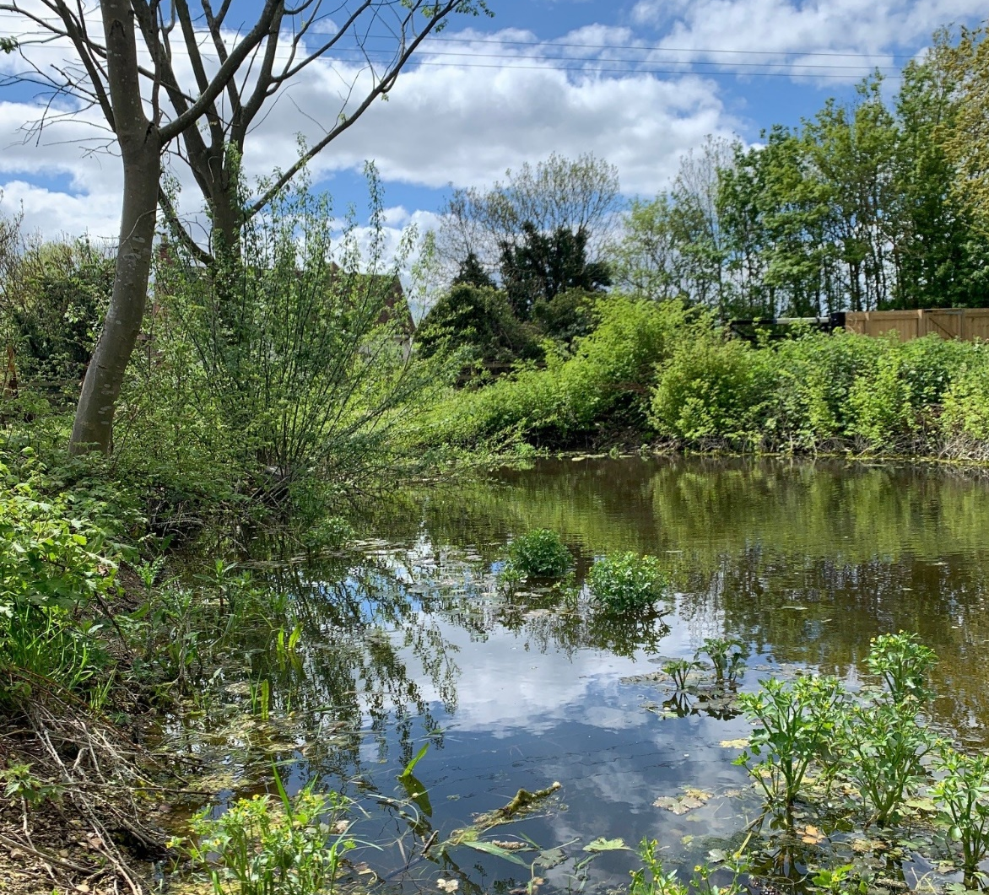
A great crested newt – Credit Lucy Jenkins, FWAG East
